Native American Sunday 2021

Faith United Methodist Church has designated April 25 to celebrate Native American Sunday (in accordance with the reconciliation agreement between Native American United Methodist Churches and the greater UMC).

Who are our Native Americans? They are those people belonging to indigenous tribes in the continental US including Alaska. There are more than five million Native Americans in the United States, belonging to at least 575 tribes and further tribes that are not federally recognized.

The three Native American United Methodist churches in the Upper New York Annual Conference are
- Four Corners United Methodist Church, located on the Cattaraugus Territory
- Hogansburg United Methodist Church located on the St. Regis Mohawk Reservation at Akwesasnee
- Onondaga Nation United Methodist Church located on the Onondaga Nation Indian Territory.

Funds we contribute to our special collection provides ongoing support for education, cultural preservation, and social justice for Native American communities in the United States and particularly within our conference. Our gifts will fund scholarships for Native American seminarians, strengthen and develop Native American ministries and communities, and support Native American outreach in annual conferences.

Students from Rontewennanonhnha School thank the Upper New York Annual Conference of the United Methodist Church for generous support. Through the Native American Outreach Transportation Program, Elders on the Onondaga Nation and in the greater Syracuse area obtain transportation to doctor appointments, medical treatments, food pantries, senior nutrition sites, and other necessary places.

The Native American Sunday celebration according to The Book of Discipline “serves to remind the Church of the gifts and contributions made by Native Americans to our society.” I would like to remind you today about someone who has been in the news recently. Congresswoman Deb Haaland was appointed Secretary of the Interior by President Biden and is the first Native American in a cabinet secretary role. She oversees 500 million acres of federal lands, 62 national parks and work with 1.9 million Indigenous Americans. The interior secretary also manages the Bureau of Trust Funds Administration, which handles Native American finances, and the Bureau of Indian Education.

Ms Haaland, a Democrat from New Mexico, is a member of the Laguna Pueblo tribe. Members of the tribe supported her appointment with a petition. The new cabinet secretary is expected to .play a key role in Native American affairs especially to help repair the government to government relationship with Tribes. She is also expected to play a key role in implementing the administration's environmental policies. The Interior Department has historically clashed with Native American groups. For instance, many of the nation's national parks, like Yellowstone, were cut out of Indigenous land by the US government.

There are presently four Native Americans in congress, all women. Through the years there have been some 19 of both sexes and from both parties. Republican Vice President, Charles Curtis from the Kew tribe was elected with Herbert Hoover in 1929.
Native Americans contribute a needed viewpoint to our society, particularly the idea that environment is important, not only to US but to the entire world.

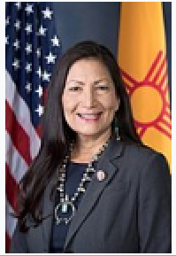

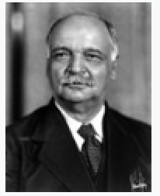

P.S. Native Americans have served in the U.S. military in every major conflict for more than 200 years. They have served ably and in record numbers. I may have an opportunity to talk about this another time.

.

